**Journey Thru The Bible**

**MARY AND ELIZABETH (TWO WOMEN BLESSED BY GOD)**

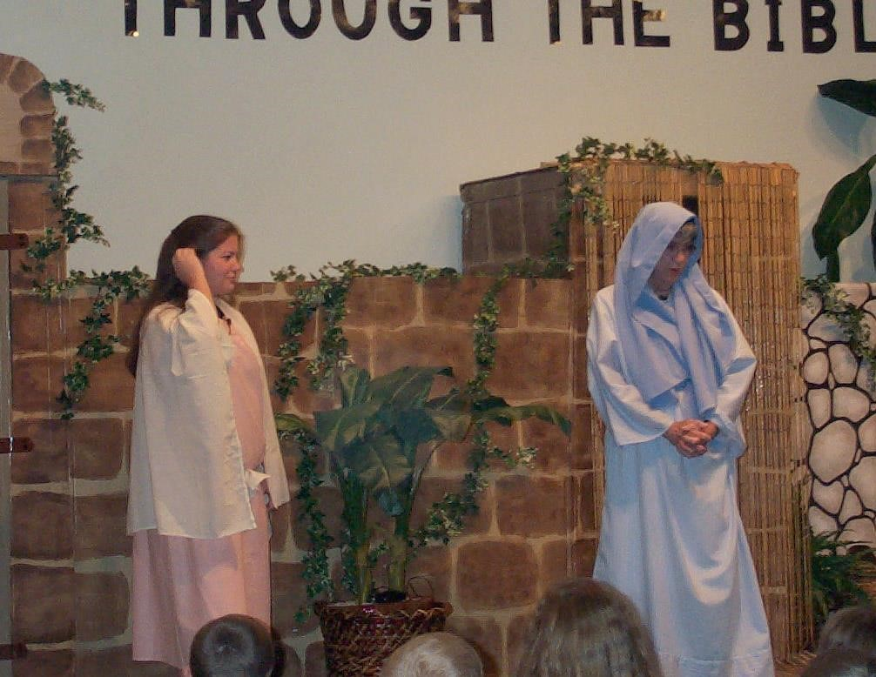

*Elizabeth:* My name is Elizabeth. I am a Jew, a descendant of Aaron, and I am married to Zechariah, a priest. For many years, my husband and I suffered the disgrace of not having children. Then one wonderful day, the angel Gabriel visited Zechariah and promised that I would bear him a son who would be called John. Because we were getting on in years, Zechariah could hardly believe what was said by Gabriel.

Gabriel said to Zechariah…”Because you did not believe my words which will be fulfilled in their time, you will not be able to speak until these things occur.” When Zechariah came out of the sanctuary, the people realized that he had seen a vision. He remained unable to speak until after John was born.

I remained at home for five months. These are the words I spoke, “This is what the Lord has done for me when

he looked favorably on me and took away the disgrace I have endured among my people.”

*Mary:* My name is Mary. I live in Nazareth, a town in Galilee. Elizabeth is a relative of mine. When I was a young, virgin girl, I was promised to be the wife of a devout Jewish carpenter named Joseph. Joseph was of the house of David.

One day before I was married, the angel Gabriel visited me in the sixth month after he visited Elizabeth with these words, “Greetings, favored one! The Lord is with you.” I was scared and confused, but the angel said, “Do not be afraid, Mary, for you have found favor with God. You will bear a Son, and you will name Him Jesus. He will be great and will be called the Son of the Most-High, and the Lord God will give to Him the throne of His ancestor, David. He will reign over the house of Jacob forever, and of His kingdom there will be no end.”

I asked the angel how this could be, since I was not married. The angel said, “The Holy Spirit will come upon you, and the power of the Most-High will overshadow you; therefore, the child to be born will be holy; He will be called Son of God. And now, your relative Elizabeth in her old age has also conceived a son, and this is the sixth month for her who was to be barren. For nothing is impossible with God.”

I said, “Here am I, the servant of the Lord; let it be with me according to your word.” The angel departed.

I quickly went to a town in Judea in the hill country to visit Zechariah and Elizabeth. I greeted Elizabeth.

*Elizabeth:* When I heard Mary’s greeting, my child leaped in my womb. I was filled with the Holy Spirit and exclaimed with a loud cry. “Blessed are you among women, and blessed is the fruit of your womb. And why has this happened to me, that the mother of my Lord comes to me? For as soon as I heard the sound of your greeting, the child in my womb leaped for joy. And blessed is she who believed that there would be a fulfillment of what was spoken to her by the Lord.”

*Mary:* My beloved Son is Jesus, the only begotten Son of God.

*Elizabeth:* My son is John the Baptist, who was the forerunner of our Savior, Jesus Christ.

*Both Women:* How greatly has God blessed us!

*Elizabeth:* Our journeys were from the book of Luke.

*Mary:* We will now ask you some questions about our Bible Character. (Prepare several questions about your

characters).

Point to remember: “For nothing is impossible for God.”

Questions:

Did Mary love and obey God?

Yes, she wanted God to use her to do His will

